Before your appointment:  Prior to your appointment I will need some basic information on yourself and your horse so I can ensure to be as prepared for your appointment as possible. This interactive form will be sent to you via email or text and will need to be filled in prior to the appointment.  I will need to have accurate directions to find the horse, ideally what-three-words if the yard is tricky to find!  On the day of the appointment:  The appointment will last 1-1.5 hours.  I will require the horse to be clean and dry. The horse will need it’s bridle and saddle, they do not need to be tacked up for me, but please have the tack ready. Please have the horse’s usual saddle pad, girth, and any pads you usually use (pro-lite, sheepskin etc).  I will need to be able to have somewhere safe, secure and level to complete the fitting. The horse will need to be tied up somewhere secure. And there needs to be a safe arena or secure field to see the horse ridden.  Saddle fitting guide. |  | When I have met yourself and your horse, I will ask for all necessary information on yourself and your horse and then assess the horse’s conformation and assess their back for any areas of pain, tightness or atrophy that may have been linked to the saddle fit. I will take the horse’s templates and see the horse in walk and trot in-hand. Following this, I will assess either their current saddle or a new saddle if you wish to purchase a new saddle. I will make any necessary adjustments if needed on site. As long as the saddle fits statically, I will see the horse ridden in your usual way. And then if the horse and rider are happy, the appointment will be over.  What to expect on the day of the fitting: |  | Frequently asked Questions:  Q- Will I need to ride?  A- Yes, the horse’s usual rider will need to ride on the day of the appointment.  Q- How will I need to pay for the fitting?  A- Payment can be accepted on the day via cash or BACS, or within the following 7 days by BACS.  Q- What if I need to cancel?  A- Please cancel as soon as possible.  Q- How much will the appointment cost?  A- My prices are listed on my website. There will be a fitting fee, milage fee and any potential adjustment fees
Contact details:  07741293725  freeequinesaddlefit@outlook.com |  | 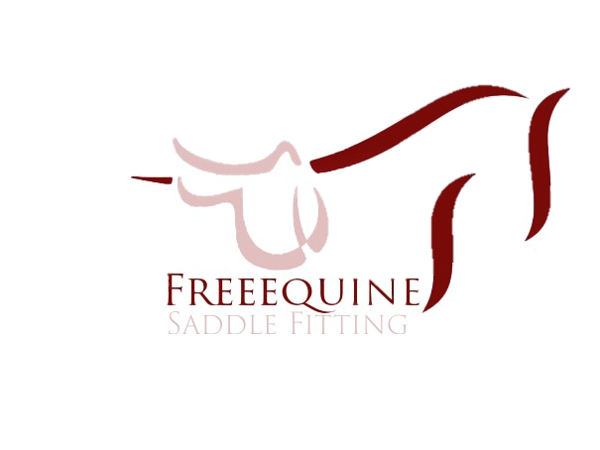 |  | I recommend your saddle is checked every 6 months, or more frequently if your horse is young, their workload has changed or if you have a new saddle.  If you have any issues with the fit of your saddle, please contact me and I will do my best to help as quickly as possible.

